# Team members:

TOLEUBEK ABDULLA

ULPAN OMIRBEKKYZY

YERSULTAN ABDRASHIT

NURGAZY MIRAS

**ASSIGNMENT 8**

**General Requirements**

Website must include at least **3–5 pages** (page types depend on your chosen topic).

Pages must share a **consistent design** (header, footer, fonts, colors).

Every page must contain:

* **Header**: logo/title + navigation bar
* **Main content area**: topic-specific content (projects, posts, products, etc.)
* **Footer**: copyright, contact info, or extra navigation links

Website must be **responsive** (desktop, tablet, mobile).Must use **Bootstrap Grid system** for layout.Must apply **custom CSS** for styling.Must include **at least one interactive component** (gallery, carousel, accordion, modal, etc.).Must use **JavaScript and/or jQuery** for interactivity (form validation, effects, animations).

***PAGE 1***

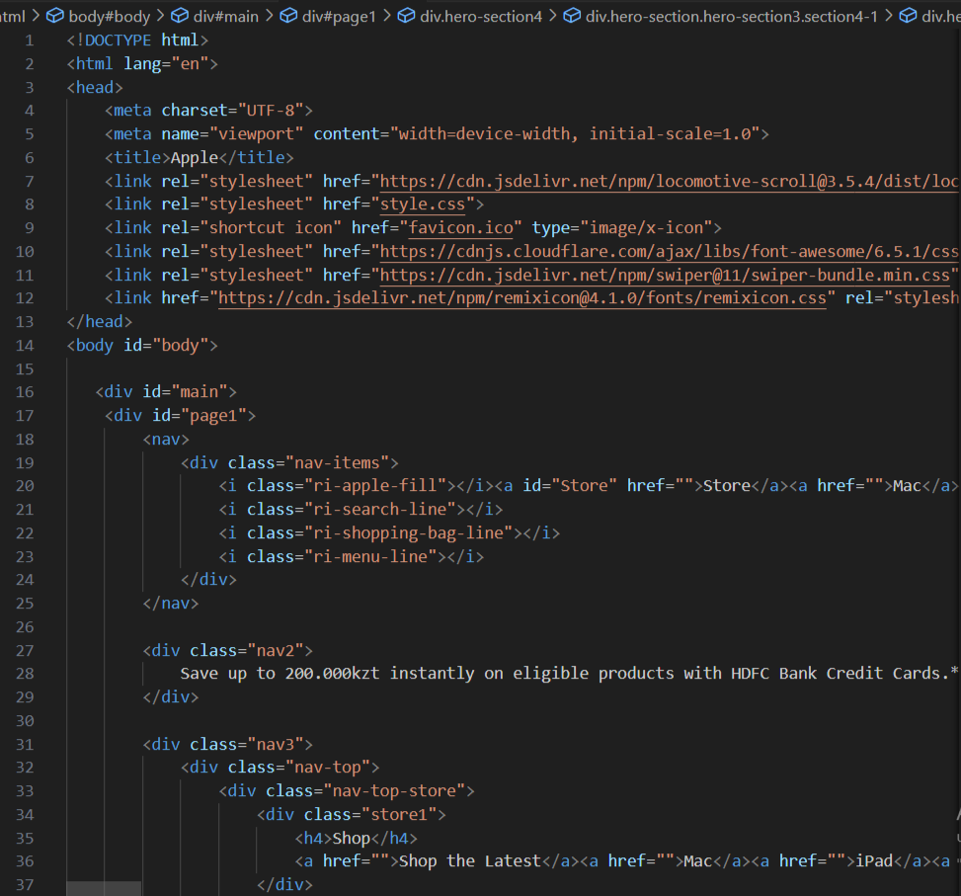 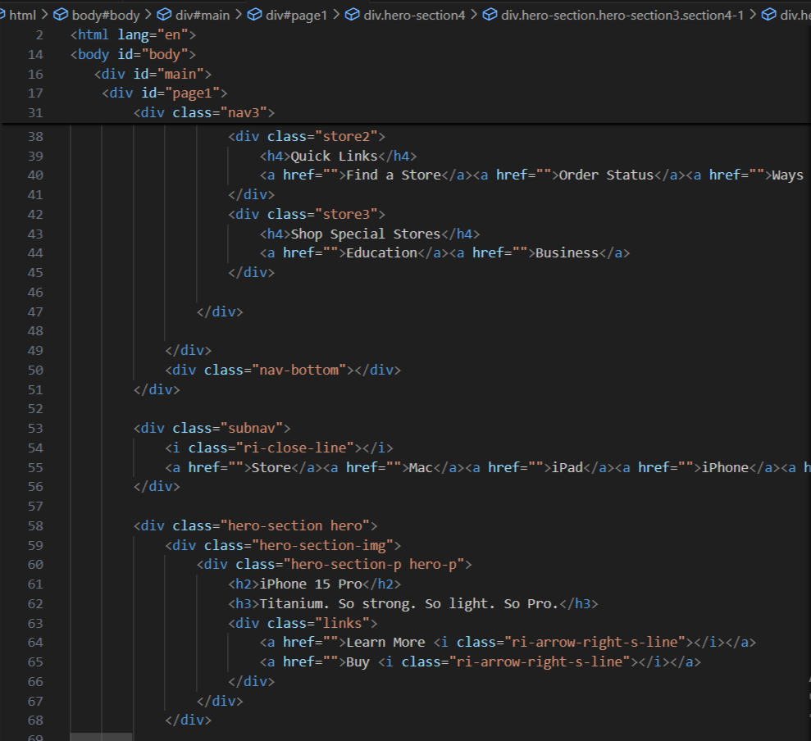

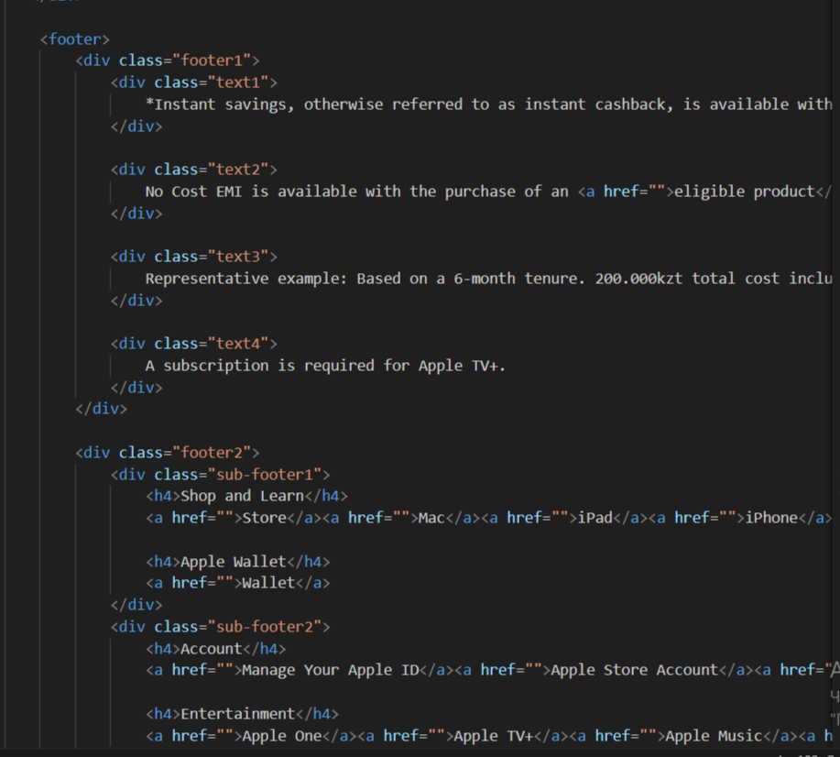 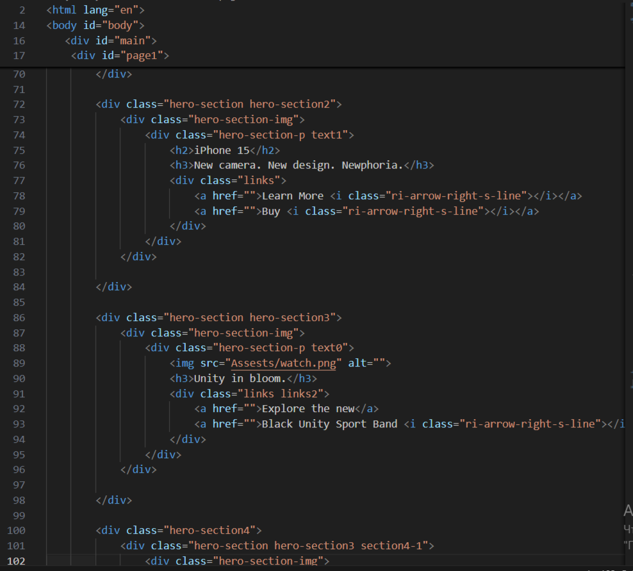

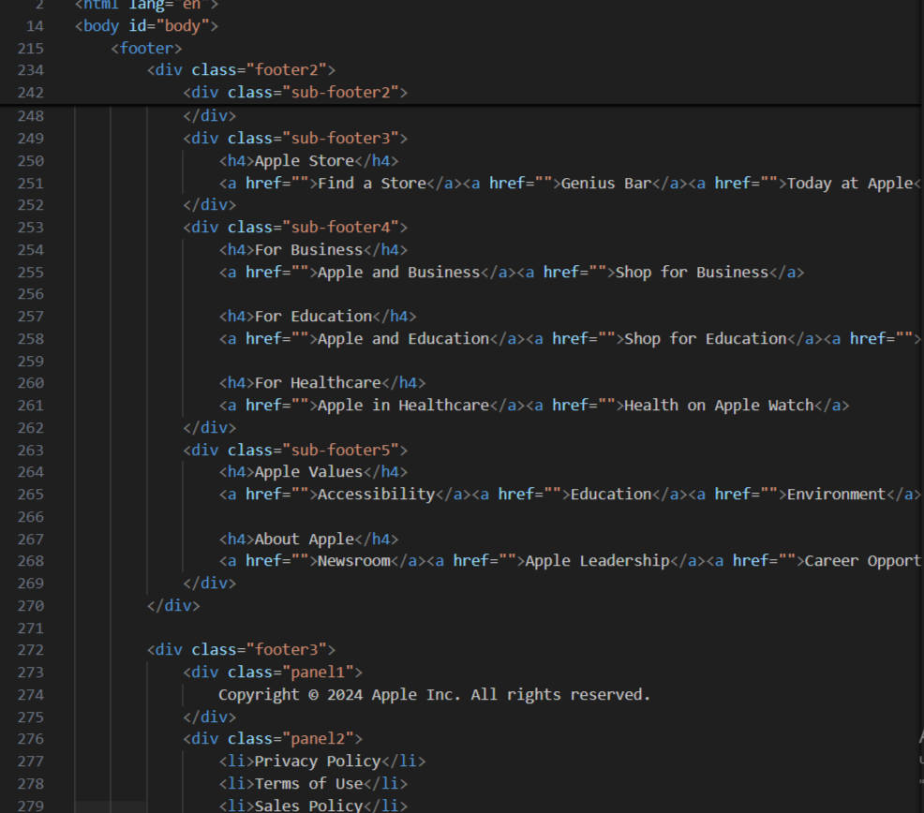 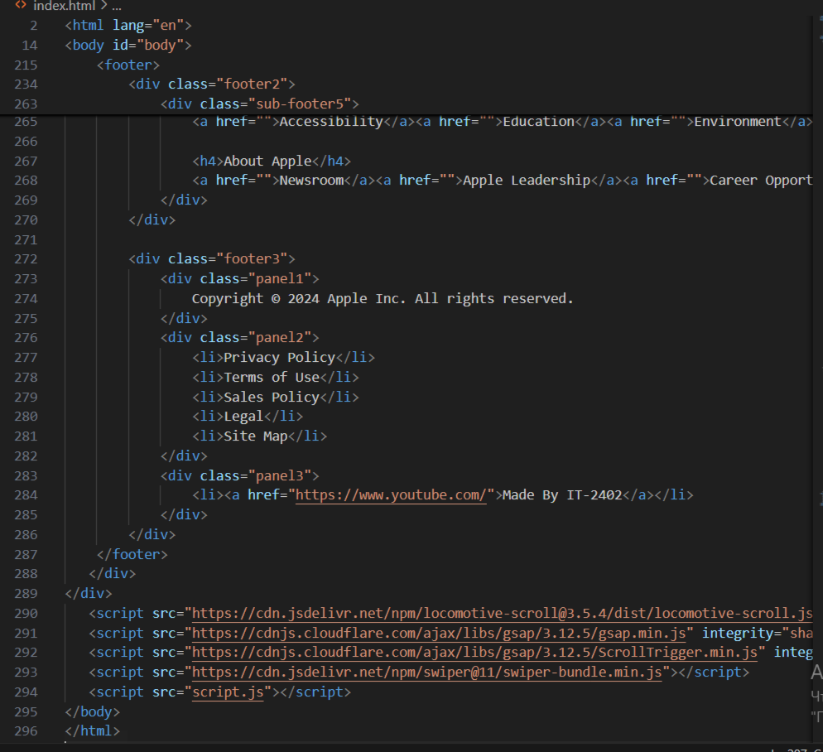

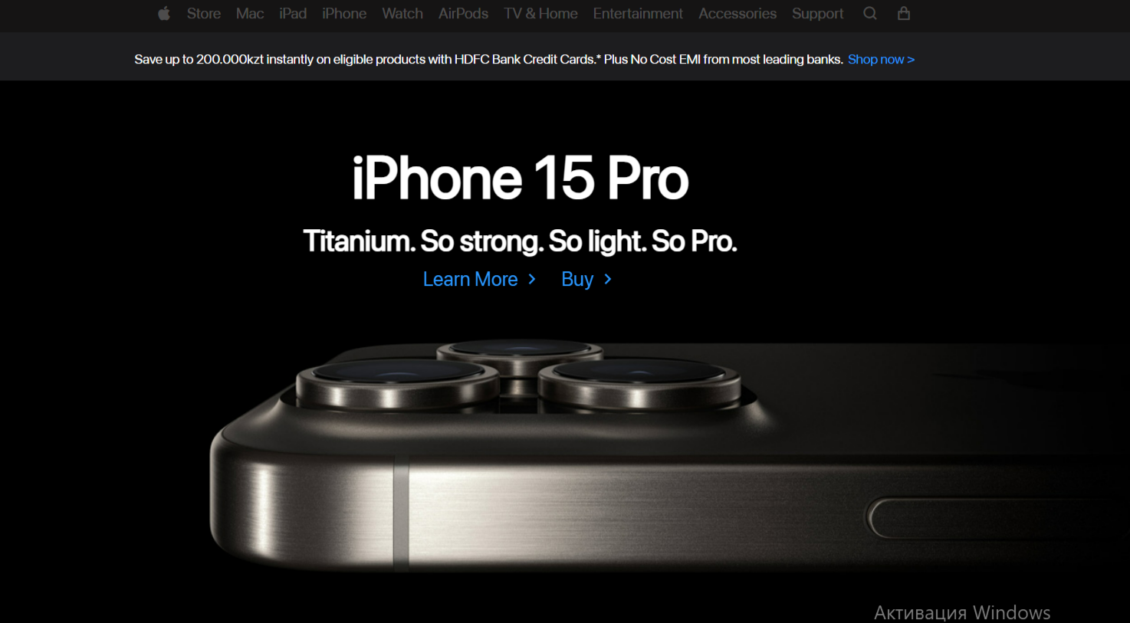

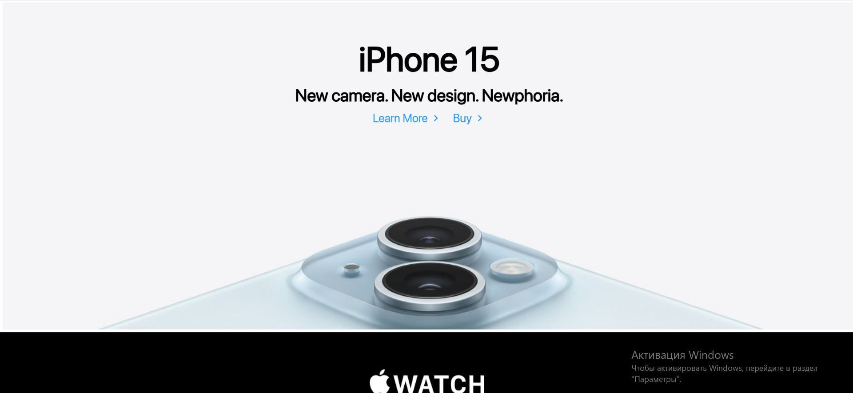



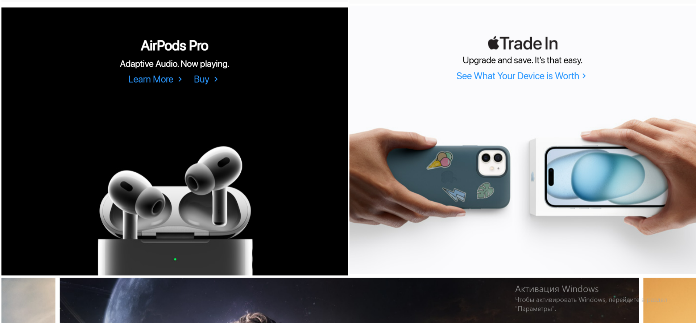

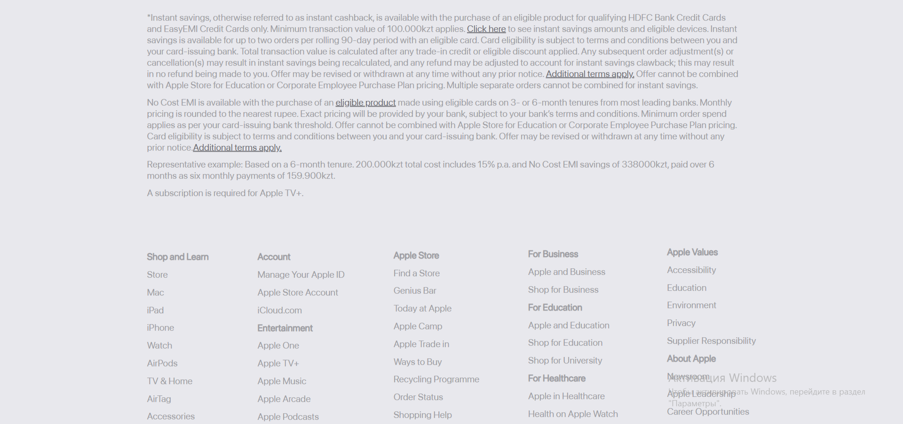

This HTML project recreates a modern, responsive Apple-style homepage. It includes a navigation bar with product links, promotional banners, hero sections highlighting Apple devices like iPhone, MacBook, and Watch, as well as an interactive image slider. The design also features a detailed footer with company and store information. External libraries such as GSAP, Swiper, and Locomotive Scroll are used to add smooth animations and scrolling effects for a sleek, professional look.

***PAGE 2***

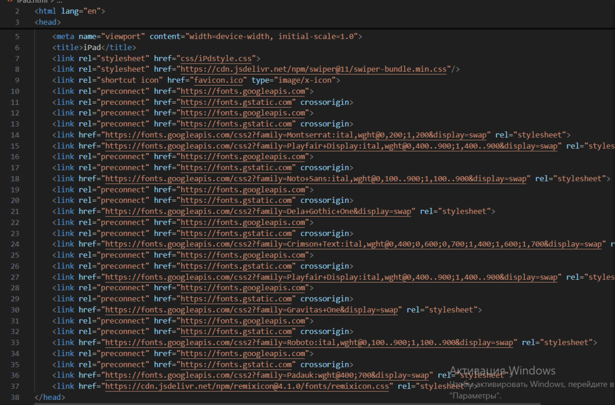

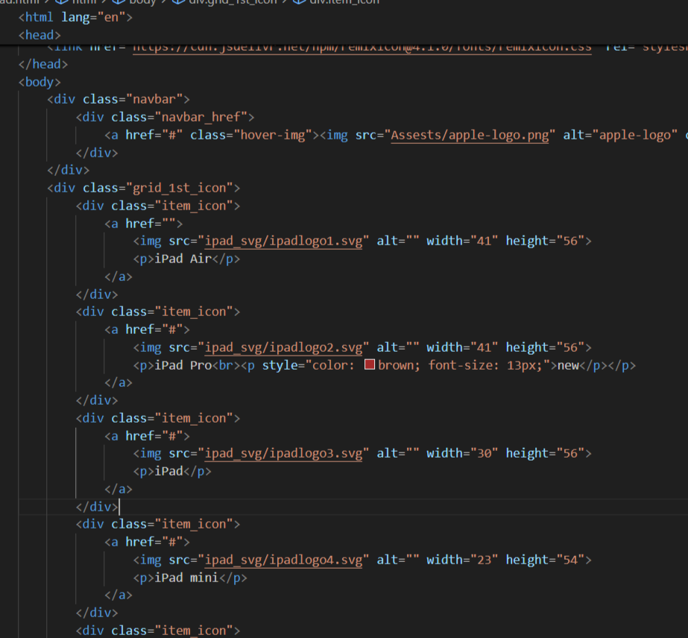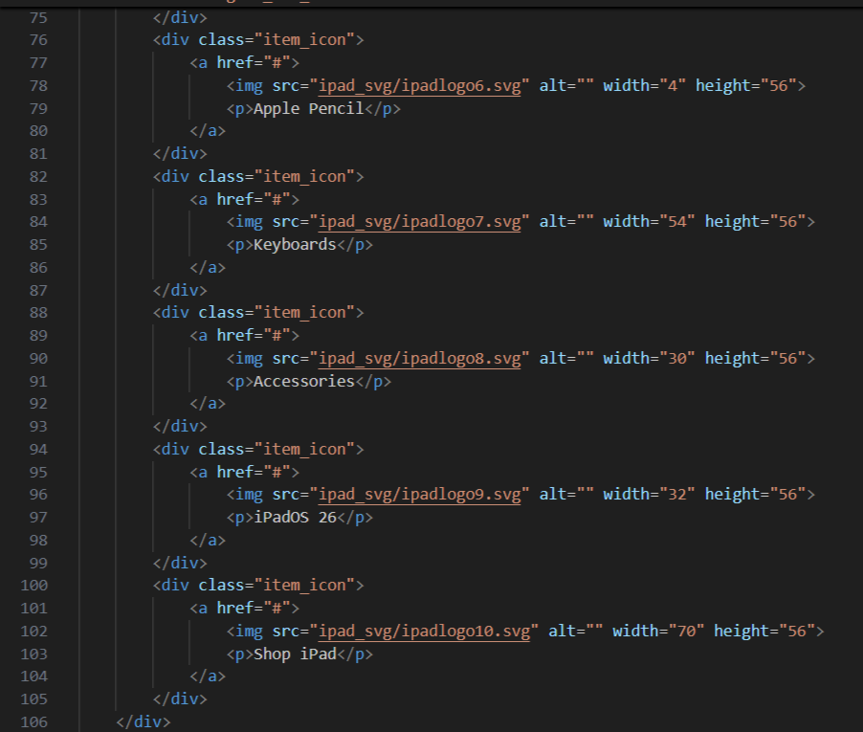

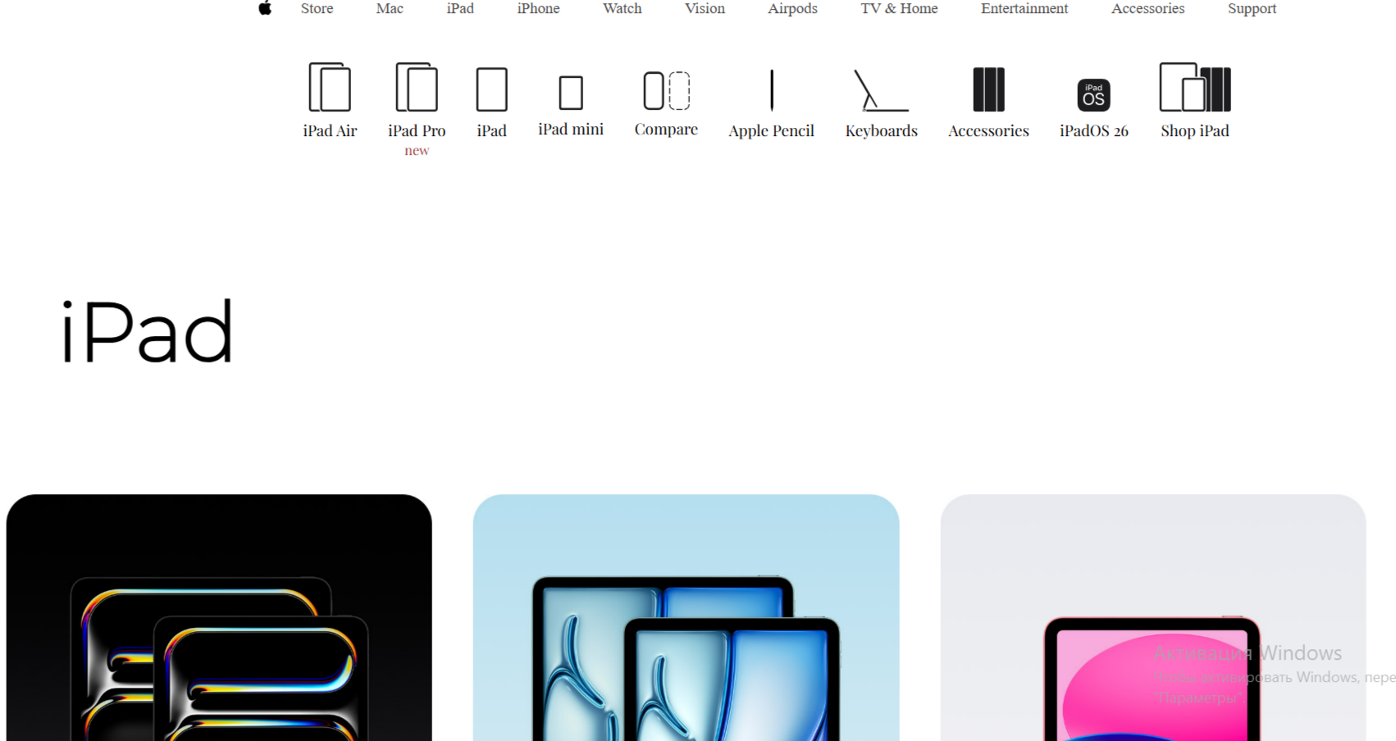

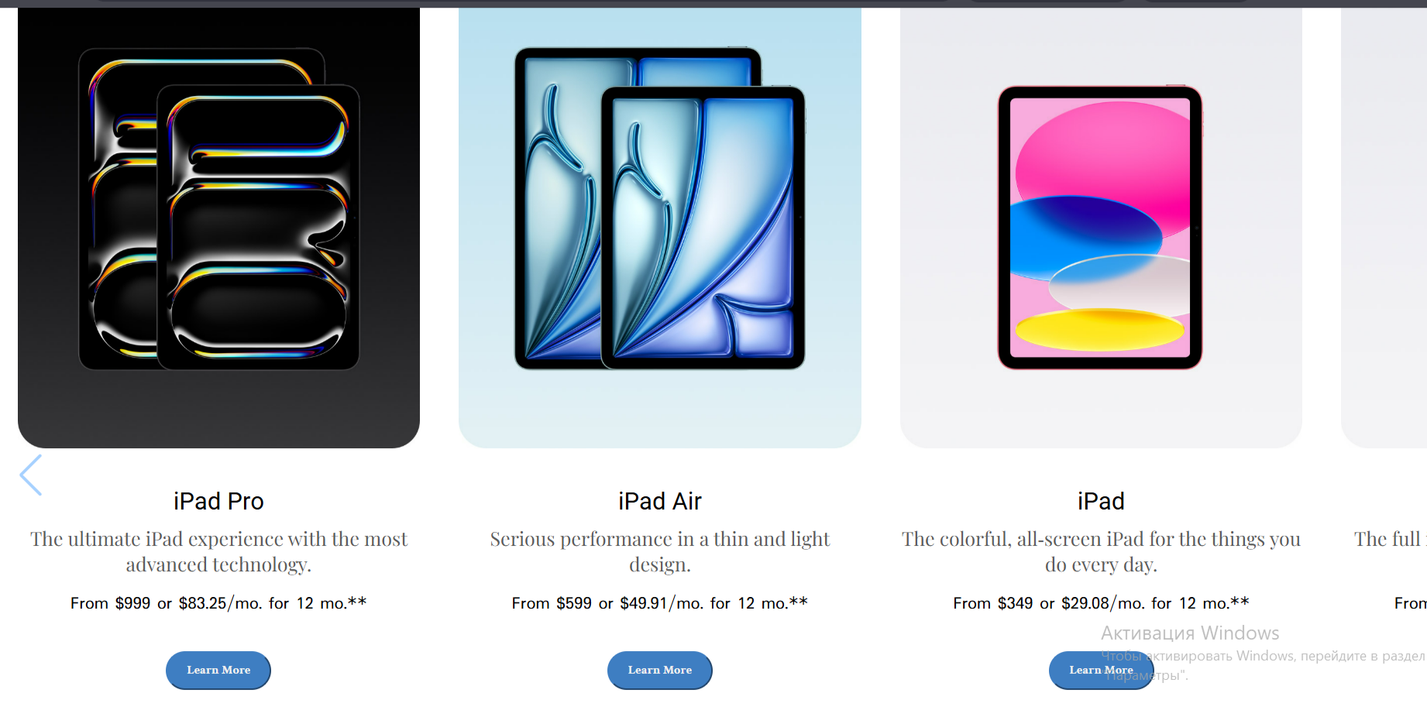

This HTML page is a dedicated Apple-style iPad section that showcases various iPad models in a clean, responsive layout. It features a fixed navigation bar, an icon grid for quick product access, and a Swiper slider displaying iPad models like iPad Pro, Air, and Mini with images, descriptions, and prices. The footer provides detailed company, product, and service information. The page uses modern fonts, smooth transitions, and responsive design to reflect Apple’s elegant and minimal aesthetic.

***PAGE 3***

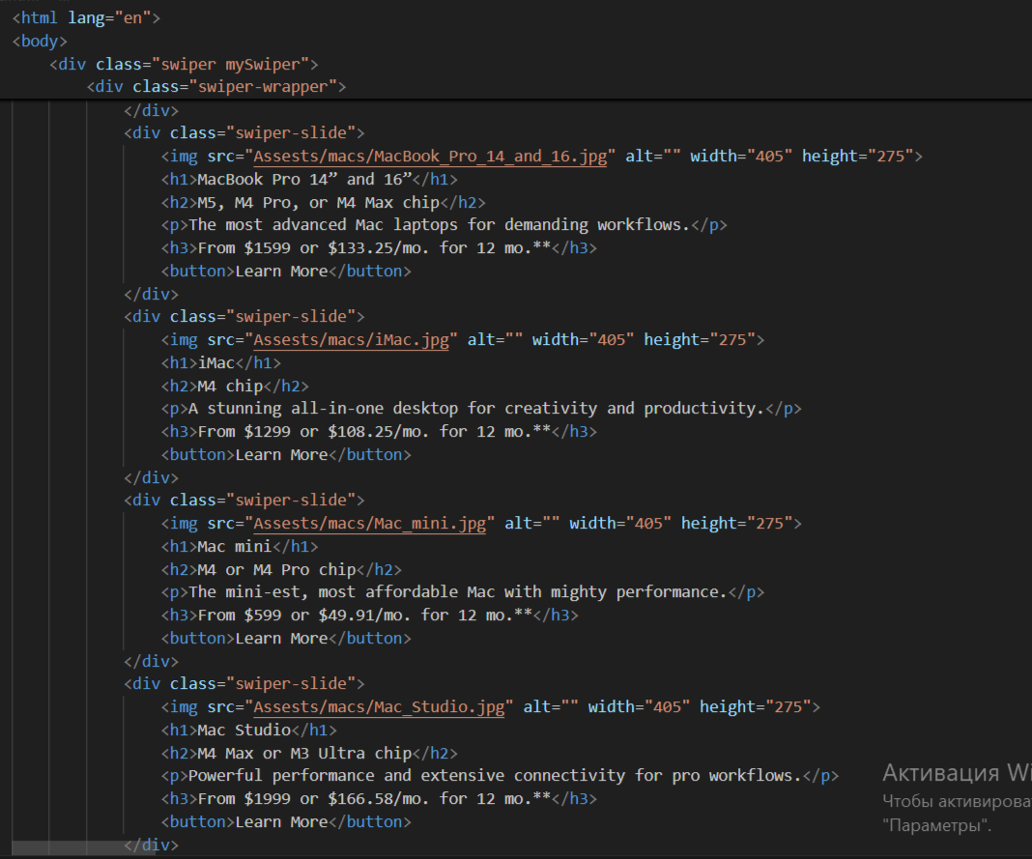

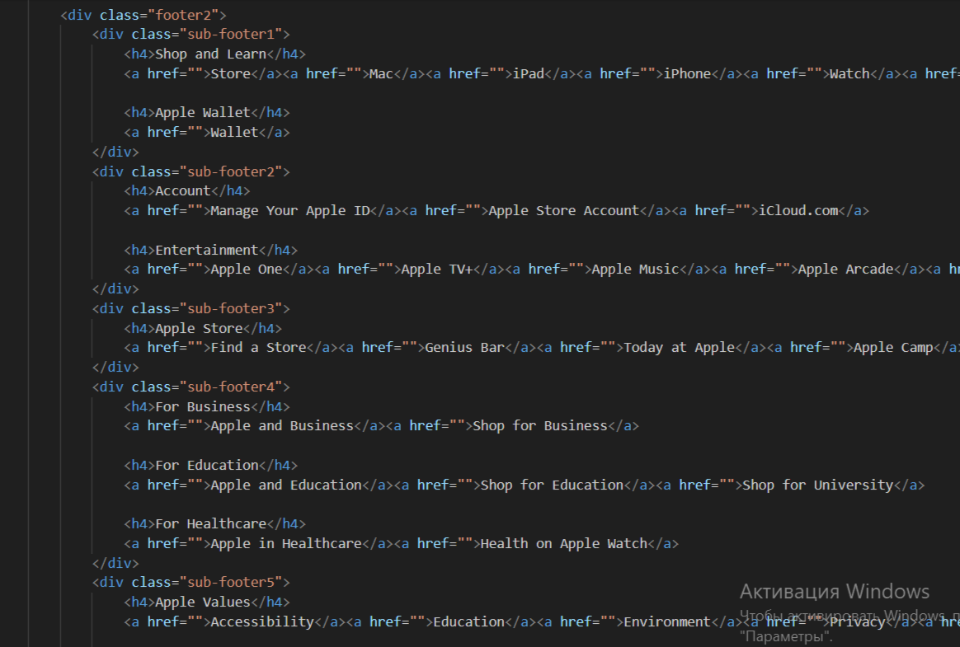

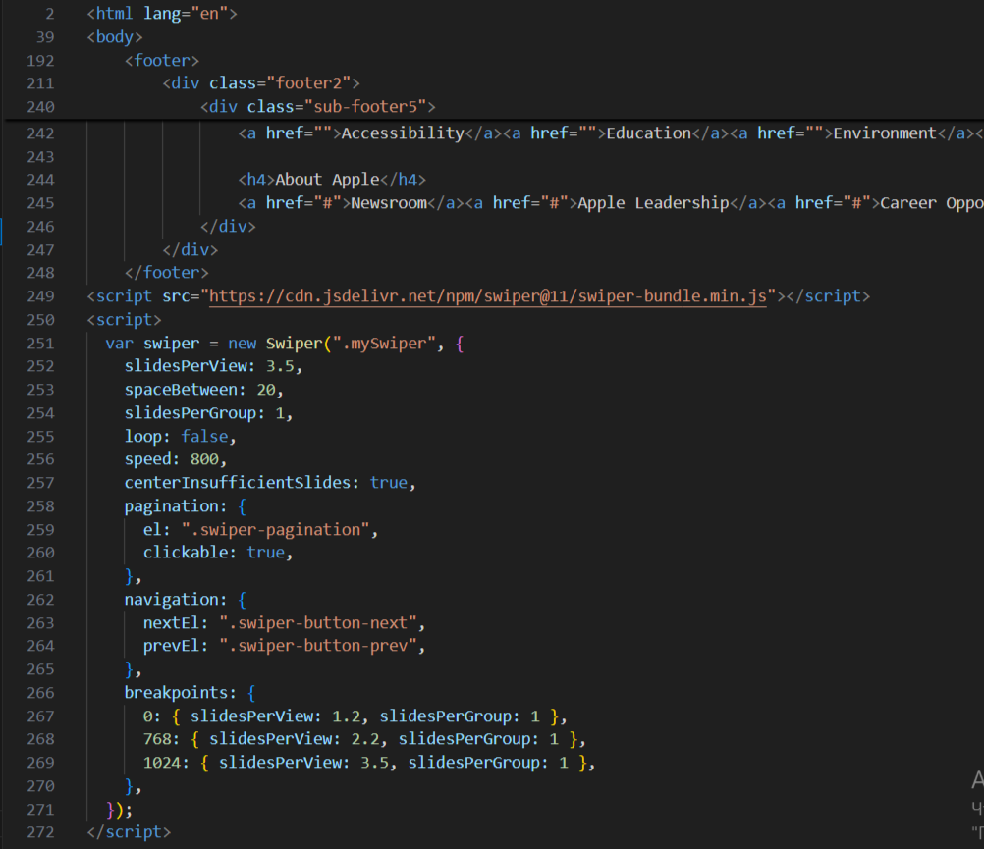

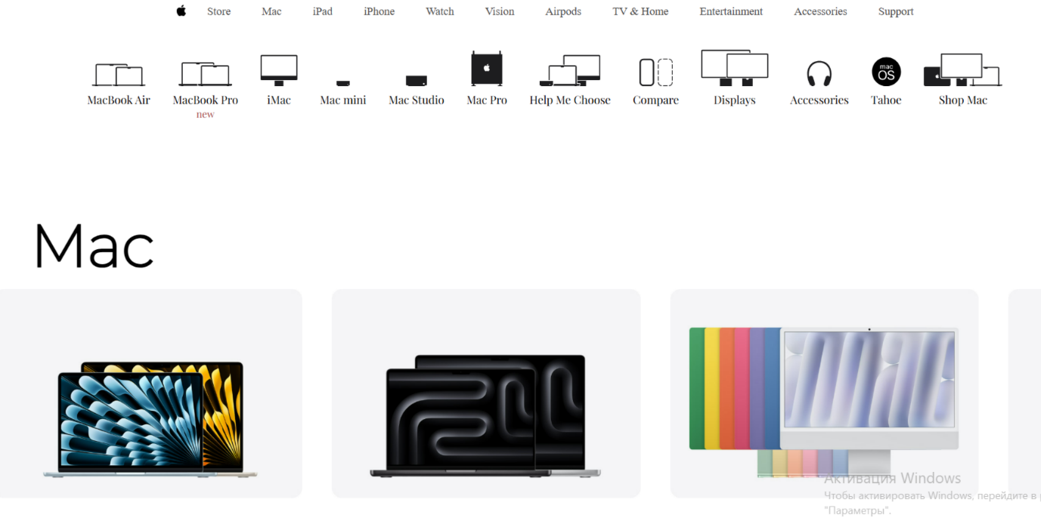

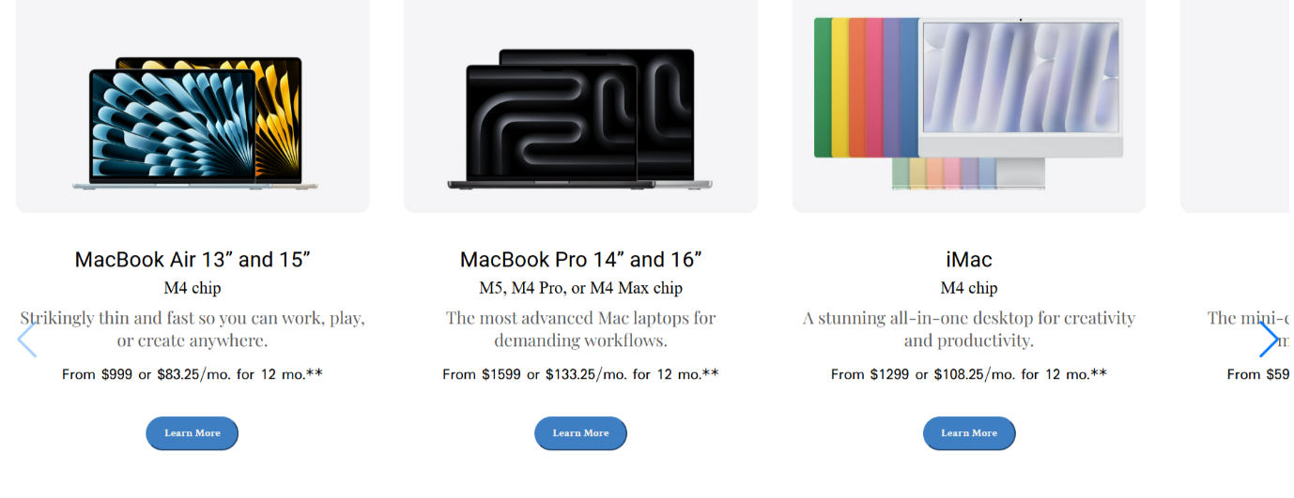

This HTML project recreates Apple’s official Mac page with a modern and responsive design. It features a navigation bar, product icon grid, and an interactive Swiper slider showcasing different Mac models like MacBook Air, MacBook Pro, and iMac with images, details, and prices. The page includes elegant typography, smooth transitions, and a detailed footer with store and company information, reflecting Apple’s clean and minimal aesthetic.

***PAGE 4***

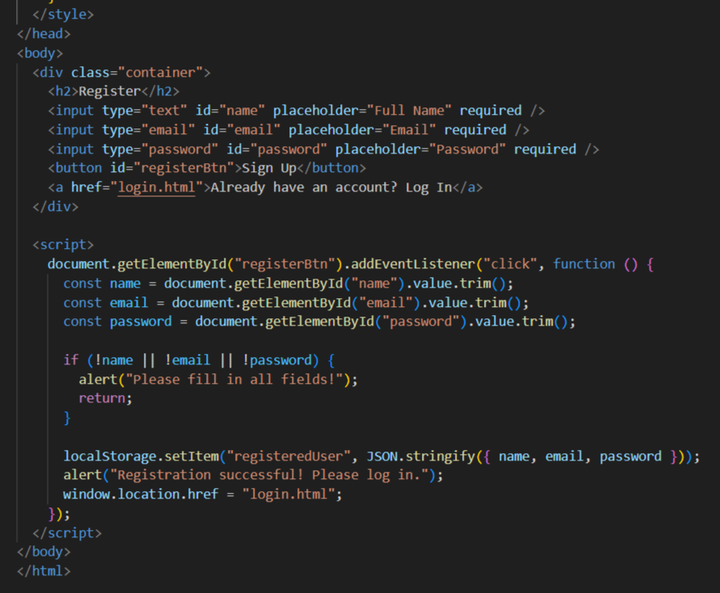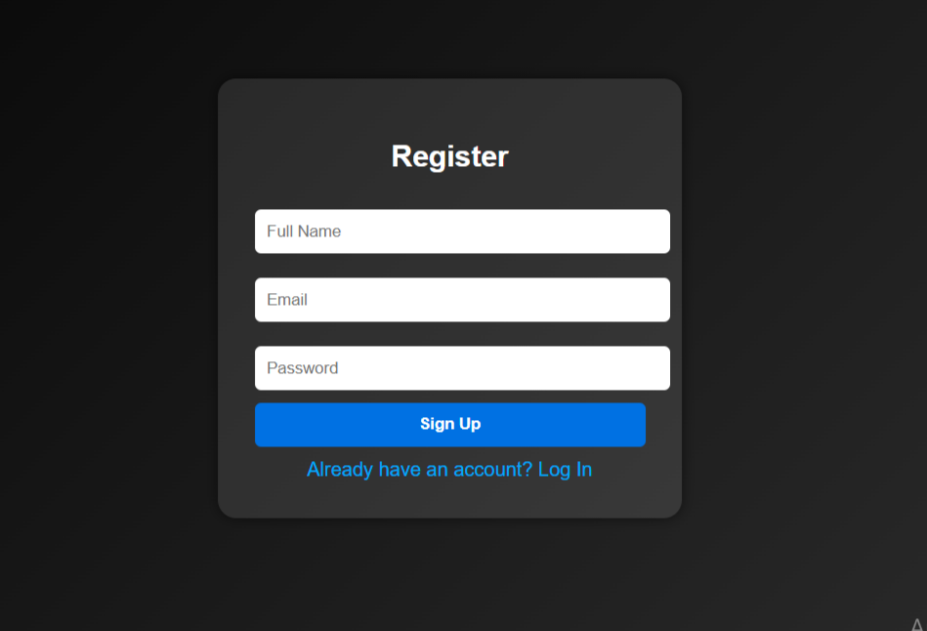

This HTML page is a simple and modern **registration form** designed with a dark gradient background and smooth rounded styling. It allows users to create an account by entering their name, email, and password. Upon submission, the data is stored in the browser’s local storage, and the user is redirected to the login page. The interface is clean, minimal, and fully responsive, following Apple-inspired aesthetics with soft transitions and intuitive layout.

***PAGE 5***

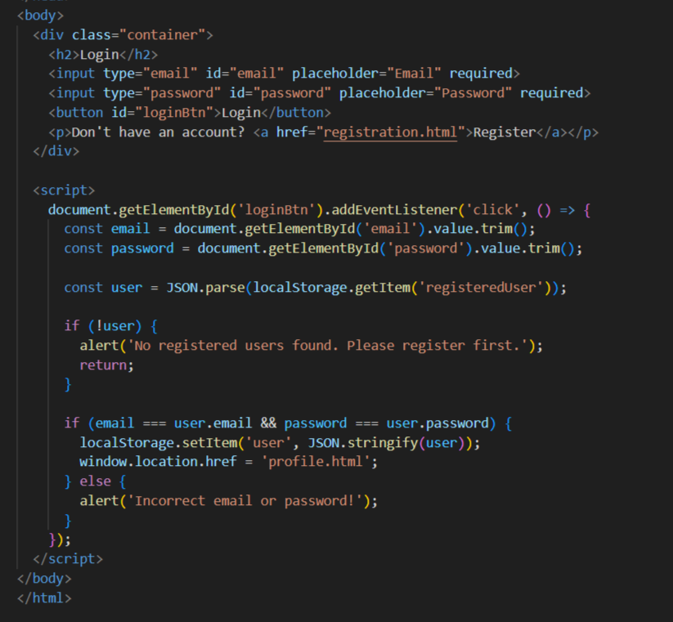

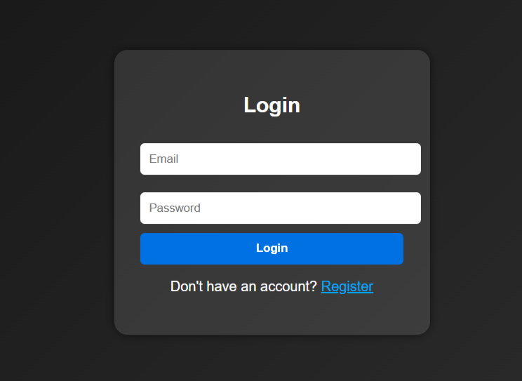

This HTML page is a clean and responsive **login form** built with a sleek dark gradient design. It allows users to log in using the credentials saved during registration. The system verifies the entered email and password against data stored in local storage. If valid, the user is redirected to the profile page; otherwise, an error alert appears. The layout is minimal, modern, and user-friendly, maintaining a consistent Apple-inspired visual style.

***PAGE 6***

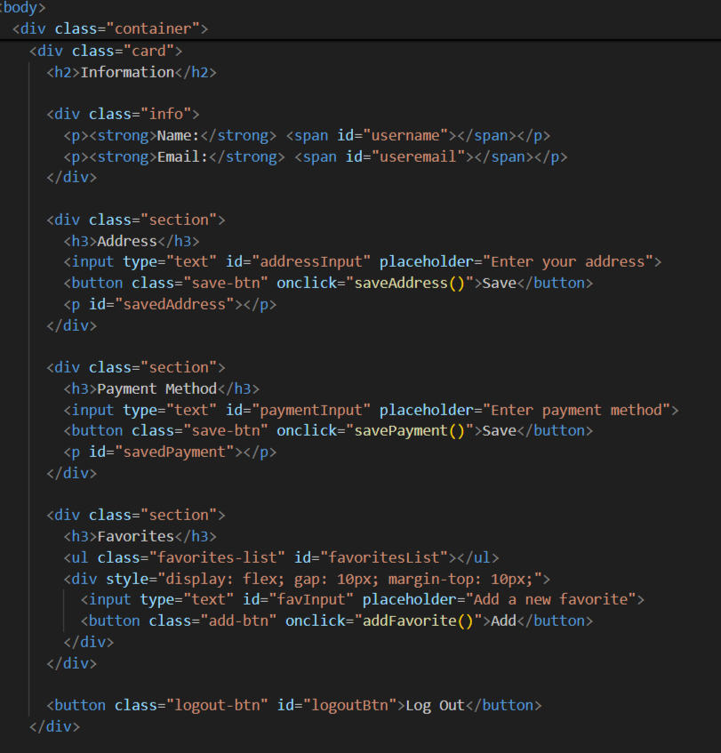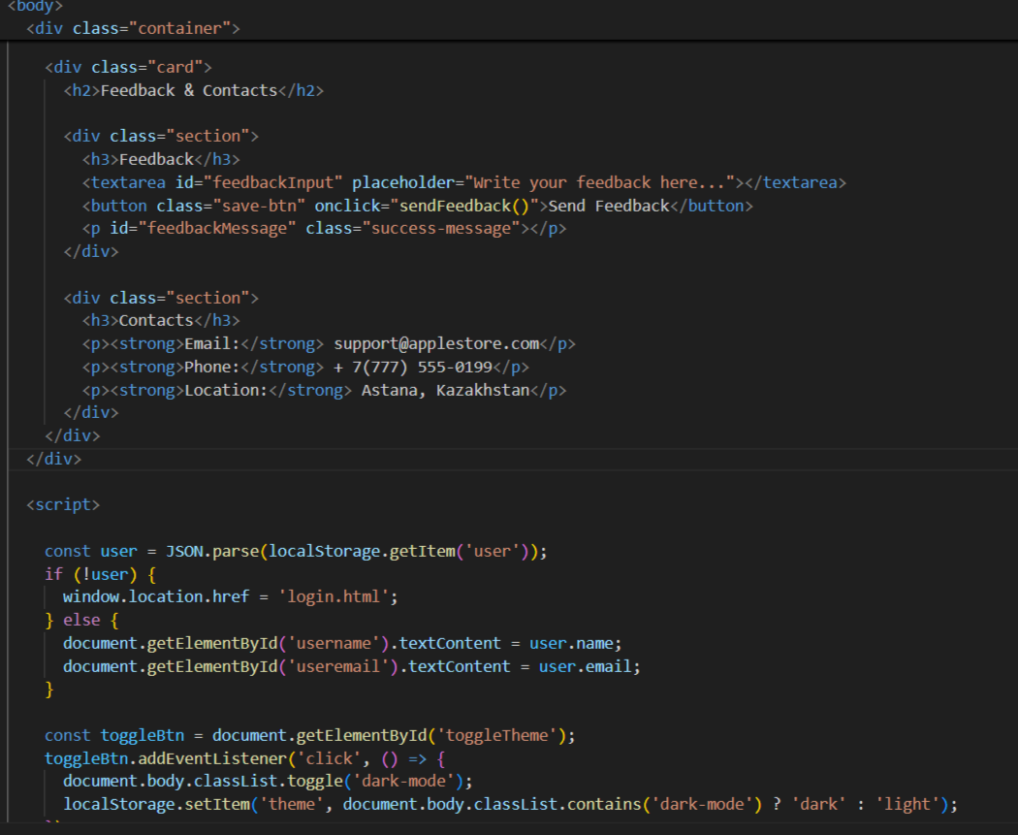

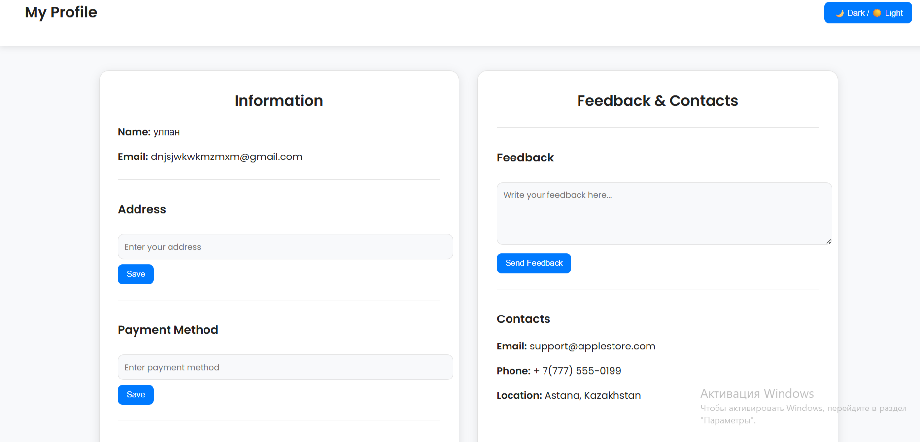

This HTML page is a **modern user profile interface** designed with light and dark mode support and smooth transitions. It displays the logged-in user’s name and email, allows editing and saving of address and payment details, and lets users manage their list of favorite items directly in local storage. The page also includes a feedback section with a success message after submission, plus contact information for support. The layout is elegant, minimalistic, and consistent with the Apple-inspired design of the registration and login pages.

***SUMMARY***

This project represents a complete and elegant **Apple-inspired user system** that includes registration, login, and personalized profile pages. The registration page allows users to create an account by entering their details, which are securely stored in the browser’s local storage. The login page verifies these credentials and redirects users to their personal profile upon successful authentication. The profile page features a modern and responsive layout where users can view and update their personal information, save their address and payment method, manage their favorite items, and send feedback. It also includes a light and dark mode toggle for a customizable experience. Overall, the project demonstrates a clean, user-friendly, and aesthetically refined web application that combines functionality, simplicity, and professional design.

***REFERENCES:***

Apple Inc. (n.d.-a). *iPhone 15 Pro – Apple*. Apple. <https://www.apple.com/iphone-15-pro/>

Apple Inc. (n.d.-b). *Shop the latest Apple products*. Apple. <https://www.apple.com/shop/>

Apple Inc. (n.d.-c). *Apple Watch Series 9*. Apple. <https://www.apple.com/apple-watch-series-9/>

Apple Inc. (n.d.-d). *MacBook Pro*. Apple. <https://www.apple.com/macbook-pro/>

Apple Inc. (n.d.-e). *iPad*. Apple. <https://www.apple.com/ipad/>

Apple Inc. (n.d.-f). *Design – Apple*. Apple. <https://www.apple.com/design/>

Cascading Style Sheets Level 3 (CSS3). (2019). *W3C recommendation*. World Wide Web Consortium. <https://www.w3.org/TR/CSS/>

HTML Living Standard. (2023). *Web Hypertext Application Technology Working Group (WHATWG)*. <https://html.spec.whatwg.org/>

JavaScript. (2023). *ECMAScript® 2023 language specification* (14th ed.). Ecma International. <https://tc39.es/ecma262/>

Remixicon. (2023). *Open source icon library*. [https://remixicon.com](https://remixicon.com/)

Github Link:

https://abxdugga.github.io/FINAL_PROJECT_/